Zachary Frye
CSC 500
Module 5 Critical Thinking Assignment
Pseudocode:
Part 1:
- START
- Prompt user for number of years (year)
- Check if year is <1
  - If year < 1, prompt for positive year value
- Declare months of the year, total rainfall
- Outer for loop for year
  - Inner for loop for months
    - Prompt user for rain each month
      - If rainfall is negative, prompt for non-negative value
    - Add rainfall to total
- Calculate total number of months
- Print total rainfall
- Calculate and print average rainfall per month
- END
Part 2:
- START
- Prompt user for number of books (books)
- Check if books variable is negative
  - If books <0, prompt for non-negative value
- If books ==0 or books == 1
  - Print point total
- Repeat for other book totals
- END
Source Code:
#Zach Frye
#CSC 500
#Module 5 Assignment part 1
#2/15/2026

print("How many years of rainfall should this program calculate?") #prompt user for number of years to calculate
year = int(input())
if year < 1: #check if year is negative, if so prompt user to enter a positive integer
print("Please enter a positive integer for the number of years.")
year = int(input())
months = ["January", "February", "March", "April", "May", "June", "July", "August", "September", "October", "November", "December"] #array for months of the year
total_rainfall = 0.0 #declare total rainfall variable

for i in range(year): #for loop for year increment
for month in months: #for loop for month increment
print("How many inches of rainfall were there in " + month + " of year " + str(i+1) + "?") #prompt user for rainfall in each month of each year
rainfall = float(input()) #set rainfall variable
if rainfall >= 0: #check if rainfall is negative, if not add to total rainfall, if so prompt user to enter a non-negative number
total_rainfall += rainfall
else:
print("Please enter a non-negative number for rainfall.")
rainfall = float(input())

print("Total number of months:", year*12) #calculate and print total number of months, total rainfall, and average rainfall per month
print(f"Total inches of rainfall: {total_rainfall:.2f}")
print(f"Average rainfall per month: {total_rainfall/(year*12):.2f} inches")

#Zach Frye
#CSC 500
#Module 5 Assignment part 2
#2/15/2026

print("How many books have you purchased this month?") #prompt user for number of books purchased
books = int(input())
if books < 0: #check if number of books is negative, if so prompt user to enter a non-negative integer
print("Please enter a non-negative integer for the number of books.")
books = int(input())

if books == 0 or books==1: #print points based on number of books purchased from 0 to 1, 2 to 3, 4 to 5, 6 to 7, and 8 or more
print("You have earned 0 points.")
elif books == 2 or books == 3:
print("You have earned 5 points!")
elif books == 4 or books == 5:
print("You have earned 15 points!")
elif books == 6 or books == 7:
print("You have earned 30 points!")
elif books >= 8:
print("You have earned 60 points!")

Output:
PS C:\Users\pieor\OneDrive\Documents\school.lol4\CSU-MS-Stuff\CSC 500\Module 5>
PS C:\Users\pieor\OneDrive\Documents\school.lol4\CSU-MS-Stuff\CSC 500\Module 5> c:; cd 'c:\Users\pieor\OneDrive\Documents\school.lol4\CSU-MS-Stuff\CSC 500\Module 5'; & 'C:\Users\pieor\AppData\Local\Programs\Python\Python312\python.exe' 'c:\Users\pieor\.vscode\extensions\ms-python.debugpy-2025.18.0-win32-x64\bundled\libs\debugpy\launcher' '54783' '--' 'c:\Users\pieor\OneDrive\Documents\school.lol4\CSU-MS-Stuff\CSC 500\Module 5\ZachFrye_Module5_Assignment1.py'
How many years of rainfall should this program calculate?
1
How many inches of rainfall were there in January of year 1?
1
How many inches of rainfall were there in February of year 1?
3
How many inches of rainfall were there in March of year 1?
7
How many inches of rainfall were there in April of year 1?
9
How many inches of rainfall were there in May of year 1?
12
How many inches of rainfall were there in June of year 1?
10
How many inches of rainfall were there in July of year 1?
11
How many inches of rainfall were there in August of year 1?
15
How many inches of rainfall were there in September of year 1?
8
How many inches of rainfall were there in October of year 1?
3
How many inches of rainfall were there in November of year 1?
0
How many inches of rainfall were there in December of year 1?
2
Total number of months: 12
Total inches of rainfall: 81.00
Average rainfall per month: 6.75 inches
PS C:\Users\pieor\OneDrive\Documents\school.lol4\CSU-MS-Stuff\CSC 500\Module 5> c:; cd 'c:\Users\pieor\OneDrive\Documents\school.lol4\CSU-MS-Stuff\CSC 500\Module 5'; & 'C:\Users\pieor\AppData\Local\Programs\Python\Python312\python.exe' 'c:\Users\pieor\.vscode\extensions\ms-python.debugpy-2025.18.0-win32-x64\bundled\libs\debugpy\launcher' '62049' '--' 'c:\Users\pieor\OneDrive\Documents\school.lol4\CSU-MS-Stuff\CSC 500\Module 5\ZachFrye_Module5_Assignment1_part2.py'
How many books have you purchased this month?
6
You have earned 30 points!

Screenshots:
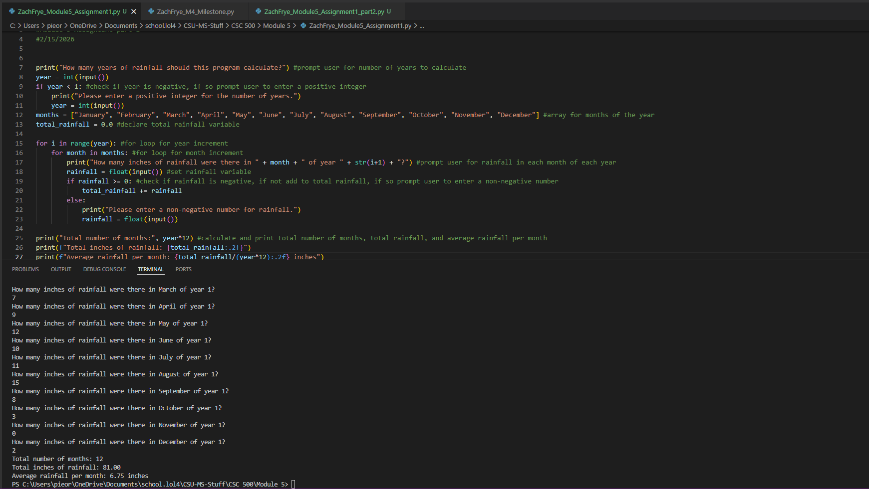

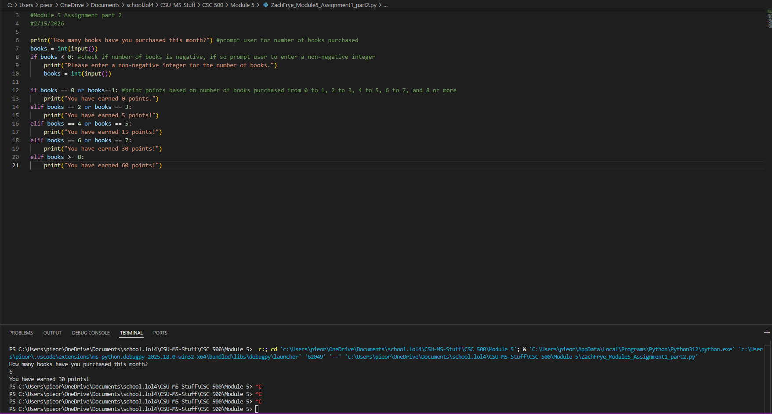
GitHub Repository

